A PROJECT REPORT ON

ONLINE ELECTRONIC SHOP

Submitted to Pramod Ram Ujagar Tiwari Saket Institute of Management for the partial fulfillment of the
requirement for the Award of Degree for

Master in Management Studies

Done by

AKASH KHOPADE

Pramod Ram Ujagar Tiwari Saket Institute of Management

CERTIFICATE

This is to certify that Mr._____________, bearing Roll No. ___ have developed Software project titled ONLINE ELECTRONIC SHOP for Pramod Ram Ujagar Tiwari Saket Institute of Management as a partial Fulfillment for the award of the Degree of Master in Management Studies.

HEAD OF DEPARTMENT PRINCIPAL
Pramod Ram Ujagar Tiwari Saket Institute of Management

EXTERNAL EXAMINER

ACKNOWLEDGMENT

My express thanks and gratitude and thanks to Almighty God, my parents and other family members and friends without whose uncontained support, I could not have made this career in COMPUTER FIELD.

I wish to place on my record my deep sense of gratitude to my project guide, Mrs .S.A.Ade , Pramod Ram Ujagar Tiwari Saket Institute of Management for her constant motivation and valuable help through the project work. Express my gratitude to Dr.M.V.Sarode , HOD of COMPUTER DEPARMENT , Government polytechnic for his valuable suggestions and advices through out the course. I also extend my thanks to other Faculties for their Cooperation during my Course.

Finally I would like to thank my friends for their cooperation to complete this project.

XXXXXXX

ABSTRACT
ONLINE ELECTRONIC SHOP is a very important feature used in e-commerce to assist people making purchases online, similar to the US English term ‘shopping cart’.
The business-to-consumer aspect of electronic commerce (e-commerce) is the most visible business use of the World Wide Web. The primary goal of an e-commerce site is to sell goods and services online.
E-commerce is fast gaining ground as an accepted and used business paradigm. More and more business houses are implementing web site providing functionality for performing commercial transactions over the web. It is reasonable to say that the process of shopping on the web is becoming commonplace.
ONLINE ELECTRONIC SHOP is a very important feature used in e-commerce to assist people making purchases any products online.
This project deals with developing an e-commerce website for online different types of gifts. It provides the user with a catalog of different types of gifts available for purchase in the store. In order to facilitate online purchase a shopping cart is provided to the user. The system is implemented using a 3-tier approach, with a backend database, a middle tier of Microsoft Internet Information Services (IIS) and ASP.NET, and a web browser as the front end client.
The ONLINE ELECTRONIC SHOP project has been developed to allow business grows larger and faster. This site will let customers to view and order products online from any part of the world. The site sells different types of. Under this website many products and services can be ordered.
Users of the system: Customer is the user of the system. An administrator of the website is the super user. When the user types in the URL of the website, a Welcome page is shown which has a menu on the left hand side, a banner at the top and any related links to other sites. This site contains an online catalog for the user. User has to login to Welcome Page before ordering anything. Login functionality should check the authenticity of the user from the database.
Functional components of the project: Following is a list of functionality of the system:
- Registration Screen: If the user is not registered, then registration screen should be available
- Products Order: This screen will show all the types of different product with their values and minimum quantity that should be ordered. If possible, provide the image of each of the product. On selecting any one of the product, user is shown the columns for the quantity to be entered. After entering the quantity, price is automatically set by the system based on the product price data. On adding to catalog, kindly check the inventory and take appropriate action.
- Catalog Information: This screen contains the information about the orders for the user. It gives total value of the order together with individual items ordered. On ordering, the validation about user’s credit is made. Credit information can be kept in the database for the sake of simplicity. Once the order is accepted, inventory is updated and shipment entry is made in the database. Once the shipment is done, shipment status is updated.
- Terms and Conditions – A Brief text on the website explaining terms and conditions and printable copy of it.
- Contact Information – Contact information regarding the office addresses with phones and faxes are provided on this screen
In order to develop an e-commerce website, a number of Technologies must be studied and understood. These include multi-tiered architecture, server and client side scripting techniques, implementation technologies such as ASP.NET, programming language (such as C#, VB.NET), relational databases (such as MySQL, Access).
This is a project with the objective to develop a basic website where a consumer is provided with a E-Gift Shoppy application and also to know about the technologies used to develop such an application.
This document will discuss each of the underlying technologies to create and implement an e-commerce website.

CONTENTS

- INTRODUCTION

INTRODUCTION TO PROJECT
ORGANIZATION PROFILE
PURPOSE OF THE PROJECT
PROBLEM IN EXISTING SYSTEM
SOLUTION OF THESE PROBLEMS

- SYSTEM ANALYSIS

  - INTRODUCTION
  - SYSTEM WORKFLOW
  - STUDY OF THE SYSTEM
  - HARDWARE & SOFTWARE REQUIRMENT
  - PROPOSED SYSTEM
  - INPUT & OUTPUT
  - PROCESS MODELS USED WITH JUSTIFICATION

- FEASIBILITY REPORT

  - TECHNICAL FEASIBILITY
  - OPERATIONAL FEASIBILITY
  - ECONOMIC FEASIBILITY

- SOFTWARE REQUIREMENT SPECIFICATIONS

  - FUNCIONAL REQUIREMENTS
  - PERFORMANCE REQUIREMENTS

- SELECTED SOFTWARE

  - INTRODUCTION TO .NET FRAMEWORK
  - ASP.NET
  - C#.NET
  - SQL SERVER

- SYSTEM DESIGN

  - INTRODUCTION
  - SYSTEM WORKFLOW
  - NORMALIZATION
  - E-R DIAGRAM
  - DATA FLOW DIAGRAMS
  - DATA DICTIONARY

- OUTPUT SCREENS

- SYSTEM TESTING AND IMPLEMENTATION

  - INTRODUCTION
  - STRATEGIC APPROACH OF SOFTWARE TESTING
  - UNIT TESTING
  - TEST

- SYSTEM SECURITY

9.1. INTRODUCTION
  - SECURITY IN SOFTWARE

- CONCLUSION

- FUTURE IMPROVEMENT

- BIBLIOGRAPHY

Chapter 1
INTRODUCTION

1.1. INTRODUCTION TO PROJECT
E-commerce is fast gaining ground as an accepted and used business paradigm. More and more business houses are implementing web sites providing functionality for performing commercial transactions over the web. It is reasonable to say that the process of shopping on the web is becoming commonplace.
The objective of this project is to develop a general purpose e-commerce store where any electronic product (such as Computers, Televisons etc.) can be bought from the comfort of home through the Internet. However, for implementation purposes, this paper will deal with an online ONLINE ELECTRONIC SHOP.
The ONLINE ELECTRONIC SHOP is a virtual store on the Internet where customers can browse the catalog and select products of interest. The selected items may be collected in a shopping cart. At checkout time, the items in the shopping cart will be presented as an order. At that time, more information will be needed to complete the transaction. Usually, the customer will be asked to fill or select a billing address, a shipping address, a shipping option, and payment information such as credit card number. An e- mail notification is sent to the customer as soon as the order is placed.

  - ORGANIZATION PROFILE

- Pramod Ram Ujagar Tiwari Saket Institute of Management (PRUTSIM) was established with the objective of providing quality management education to meet modern industry needs and to prepare students for the dynamic challenges of the business world.
- PRUTSIM was founded in 2009 under Saket Gyanpeeth. The institute focuses on developing skilled management professionals through quality education, industry interaction and value-based learning.
- The institute offers a 2-year full-time postgraduate programme – Master in Management Studies (MMS).
- PRUTSIM is affiliated to the University of Mumbai and approved by AICTE & DTE, Government of Maharashtra. It is located in Kalyan (East) and operates under Saket Gyanpeeth, which manages several educational institutions.
- PRUTSIM is a growing management institute offering the MMS programme with specializations in areas such as Marketing, Finance, Human Resources, Operations, and Systems. The institute provides essential facilities like classrooms, library, computer labs, seminar halls and supports student development through seminars, workshops and industry interaction.

  - PURPOSE OF THE PROJECT

The ONILINE ELECTRONIC SHOP needs to sell different types of products to customer living in any part of the world. The website will show all products in categorized manner. Customer can browse any product for its price and other details and can order the product. Orders needs to accompany with shipping & billing details. Customer has to pay order amount online through credit cards. Products can be managed by operators from admin panel. Operator can be created by admin. Admin can keep track of orders through admin panel.
The main purpose of the system is to enable customers to browse and order from any part of the world and hence increasing business scope.

  - PROBLEM IN EXISTING SYSTEM

- The existing system is manual system. Needs to be converted into automated system.
- Risk of mismanagement of data.
- Less Security.
- No proper coordination between different Applications and Users.
- Fewer Users - Friendly.
- Accuracy not guaranteed.
- Not in reach of distant users.

  - SOLUTION OF THESE PROBLEMS

The development of the new system contains the following activities, which try to automate the entire process keeping in view of the database integration approach.
- User friendliness is provided in the application with various controls.
- The system makes the overall project management much easier and flexible.
- There is no risk of data mismanagement at any level while the project development is under process.
- It provides high level of security with different level of authentication.
- Users from any part of the world can make use of the system.
- New system will process accurate results.
- New system will be much better in performance as compared to existing one.

Chapter 2
SYSTEM ANALYSIS

2.1. INTRODUCTION
After analyzing the requirements of the task to be performed, the next step is to analyze the problem and understand its context. The first activity in the phase is studying the existing system and other is to understand the requirements and domain of the new system. Both the activities are equally important, but the first activity serves as a basis of giving the functional specifications and then successful design of the proposed system. Understanding the properties and requirements of a new system is more difficult and requires creative thinking and understanding of existing running system is also difficult, improper understanding of present system can lead diversion from solution.
2.2. ANALYSIS MODEL
The design starts after the requirement analysis is complete and the coding begins after the design is complete. Once the programming is completed, the testing is done. In this model the sequence of activities performed in a software development project are: -
- Requirement Analysis
- Project Planning
- System design
- Detail design
- Coding
- Unit testing
- System integration & testing

Here the linear ordering of these activities is critical. End of the phase and the output of one phase is the input of other phase. The output of each phase is to be consistent with the overall requirement of the system. Some of the qualities of spiral model are also incorporated like after the people concerned with the project review completion of each of the phase the work done.
WATER FALL MODEL was being chosen because all requirements were known beforehand and the objective of our software development is the computerization/automation of an already existing manual working system.

Communicated Requirements

Requirements Specification

Design Specification

Executable Software Modules

Integrated Software Product

Delivered Software Product

Changed Requirements

Requirements Engineering
Design
Programming
Integration
Delivery
Maintenance

Product
Product

input

output

Process

Fig 2.2: Water Fall Model

2.3. STUDY OF THE SYSTEM

GUI’S
In the flexibility of the uses the interface has been developed a graphics concept in mind, associated through a browses interface. The GUI’S at the top level have been categorized as
- Administrative user interface
- The operational or generic user interface

The administrative user interface concentrates on the consistent information that is practically, part of the organizational activities and which needs proper authentication for the data collection. The interfaces help the administrations with all the transactional states like Data insertion, Data deletion and Date updation along with the extensive data search capabilities.

NUMBER OF MODULES

The system after careful analysis has been identified to be presented with the following modules:
This project is divided into 9 modules:

1. Registration Module
2. Products Browse Module
3. Products Search Module
4. Shopping cart Module
5. Shipping & Billing Module
6. Payment Module
7. Admin User Management Module
8. Admin Catalog Management Module
9. Admin Order Management Module

Entities Involved in the Project:
- Customer
- Product
- Website Administrator
- Operator
- Order

Customer: The target user of the system. A Customer is responsible for registering them to the site, browsing site, placing orders and making payments.

Product: Product is the entity, a customer looking for. A Product will be sold to the customer.

Website Administrator: An entity responsible for managing users, roles and roles privileges.

Operator: Operator is a person (entity) responsible for managing products and orders.
Order: Order is an entity which describes the business transaction.
PROJECT INSTRUCTIONS:
- Based on the given requirements, conceptualize the Solution Architecture. Choose the domain of your interest otherwise develop the application for ultimatedotnet.com. Depict the various architectural components, show interactions and connectedness and show internal and external elements. Design the web services, web methods and database infrastructure needed both and client and server.
- Provide an environment for upgradation of application for newer versions that are available in the same domain as web service target.

2.4. HARDWARE SPEDIFICATIONS
HARDWARE REQUIREMENTS:

- PIV 2.8 GHz Processor and Above
- RAM 512MB and Above
- HDD 20 GB Hard Disk Space and Above

SOFTWARE REQUIREMENTS:

- WINDOWS OS (XP / 2000 / 200 Server / 2003 Server)
- Visual Studio .Net 2005 Enterprise Edition
- Internet Information Server 5.0 (IIS)
- Visual Studio .Net Framework (Minimal for Deployment)
- SQL Server 2000 Enterprise Edition

2.5. PROPOSED SYSTEM

To debug the existing system, remove procedures those cause data redundancy, make navigational sequence proper. To provide information about audits on different level and also to reflect the current work status depending on organization/auditor or date. Required to build strong password mechanism.

2.6. INPUT AND OUTPUT

The main inputs, outputs and major functions of the system are as follows
INPUTS:
  - Customer enters his or her user id and password.
  - Operators enter his or her user id and password.
  - Admin enter his or her user id and password.
  - User requests the product description.
  - User requests the product search.
  - User orders product.
  - System requests shipping & billing address.

OUTPUTS:
- Customer receives personal and order details.
- Operator receives the personal details.
- Admin receives order details.
- Users receive requested product details.
- Users receive orders.
- System processes orders.

2.7. PROCESS MODELS USED WITH JUSTIFICATION

ACCESS CONTROL FOR DATA WHICH REQUIRE USER AUTHENTICATION

The following commands specify access control identifiers and they are typically used to authorize and authenticate the user (command codes are shown in parentheses)

USER NAME (USER)

The user identification is that which is required by the server for access to its file system. This command will normally be the first command transmitted by the user after the control connections are made (some servers may require this).

PASSWORD (PASS)

This command must be immediately preceded by the user name command, and, for some sites, completes the user's identification for access control. Since password information is quite sensitive, it is desirable in general to "mask" it or suppress type out.

Chapter 3
Feasibility Report

Preliminary investigation examine project feasibility, the likelihood the system will be useful to the organization. The main objective of the feasibility study is to test the Technical, Operational and Economical feasibility for adding new modules and debugging old running system. All system is feasible if they are unlimited resources and infinite time. There are aspects in the feasibility study portion of the preliminary investigation:
- Technical Feasibility
- Operation Feasibility
- Economical Feasibility

3.1. Technical Feasibility
The technical issue usually raised during the feasibility stage of the investigation includes the following:
- Does the necessary technology exist to do what is suggested?
- Do the proposed equipments have the technical capacity to hold the data required to use the new system?
- Will the proposed system provide adequate response to inquiries, regardless of the number or location of users?
- Can the system be upgraded if developed?
- Are there technical guarantees of accuracy, reliability, ease of access and data security?

3.2. Operational Feasibility
Proposed projects are beneficial only if they can be turned out into information system. That will meet the organization’s operating requirements. Operational feasibility aspects of the project are to be taken as an important part of the project implementation. Some of the important issues raised are to test the operational feasibility of a project includes the following: -
- Is there sufficient support for the management from the users?
- Will the system be used and work properly if it is being developed and implemented?
- Will there be any resistance from the user that will undermine the possible application benefits?

3.3. Economic Feasibility
A system can be developed technically and that will be used if installed must still be a good investment for the organization. In the economical feasibility, the development cost in creating the system is evaluated against the ultimate benefit derived from the new systems. Financial benefits must equal or exceed the costs.
The system is economically feasible. It does not require any addition hardware or software. Since the interface for this system is developed using the existing resources and technologies available at NIC, There is nominal expenditure and economical feasibility for certain.

Chapter 4
SOFTWARE REQUIREMENT SPECIFICATION

The software, Site Explorer is designed for management of web sites from a remote location.

INTRODUCTION

Purpose: The main purpose for preparing this document is to give a general insight into the analysis and requirements of the existing system or situation and for determining the operating characteristics of the system.

Scope: This Document plays a vital role in the development life cycle (SDLC) and it describes the complete requirement of the system. It is meant for use by the developers and will be the basic during testing phase. Any changes made to the requirements in the future will have to go through formal change approval process.

DEVELOPERS RESPONSIBILITIES OVERVIEW:

The developer is responsible for:

- Developing the system, which meets the SRS and solving all the requirements of the system?
- Demonstrating the system and installing the system at client's location after the acceptance testing is successful.
- Submitting the required user manual describing the system interfaces to work on it and also the documents of the system.
- Conducting any user training that might be needed for using the system.
- Maintaining the system for a period of one year after installation.

4.1. FUNCTIONAL REQUIREMENTS:

OUTPUT DESIGN

Outputs from computer systems are required primarily to communicate the results of processing to users. They are also used to provide a permanent copy of the results for later consultation. The various types of outputs in general are:
- External Outputs, whose destination is outside the organization.
- Internal Outputs whose destination is with in organization and they are the
- User’s main interface with the computer.
- Operational outputs whose use is purely with in the computer department.
- Interface outputs, which involve the user in communicating directly with

OUTPUT DEFINITION

The outputs should be defined in terms of the following points:

    - Type of the output
    - Content of the output
    - Format of the output
    - Location of the output
    - Frequency of the output
    - Volume of the output
    - Sequence of the output

It is not always desirable to print or display data as it is held on a computer. It should be decided as which form of the output is the most suitable.

For Example
    - Will decimal points need to be inserted
    - Should leading zeros be suppressed.

Output Media:
In the next stage it is to be decided that which medium is the most appropriate for the output. The main considerations when deciding about the output media are:
- The suitability for the device to the particular application.
- The need for a hard copy.
- The response time required.
- The location of the users
- The software and hardware available.
The outputs were needed to be generated as a hot copy and as well as queries to be viewed on the screen. Keeping in view these outputs, the format for the output is taken from the outputs, which are currently being obtained after manual processing. The standard printer is to be used as output media for hard copies.

INPUT DESIGN

Input design is a part of overall system design. The main objective during the input design is as given below:

- To produce a cost-effective method of input.
- To achive the highest possible level of accuracy.
- To ensure that the input is acceptable and understood by the user.

INPUT STAGES:
The main input stages can be listed as below:

- Data recording
- Data transcription
- Data conversion
- Data verification
- Data control
- Data transmission
- Data validation
- Data correction

INPUT TYPES:
It is necessary to determine the various types of inputs. Inputs can be categorized as follows:
- External inputs, which are prime inputs for the system.
- Internal inputs, which are user communications with the system.
- Operational, which are computer department’s communications to the system?
- Interactive, which are inputs entered during a dialogue.

INPUT MEDIA:
At this stage choice has to be made about the input media. To conclude about the input media consideration has to be given to;
- Type of input
- Flexibility of format
- Speed
- Accuracy
- Verification methods
- Rejection rates
- Ease of correction
- Storage and handling requirements
- Security
- Easy to use
- Portability

Keeping in view the above description of the input types and input media, it can be said that most of the inputs are of the form of internal and interactive. As
Input data is to be the directly keyed in by the user, the keyboard can be considered to be the most suitable input device.

4.2. PERFORMANCE REQUIREMENTS

Performance is measured in terms of the output provided by the application.

Requirement specification plays an important part in the analysis of a system. Only when the requirement specifications are properly given, it is possible to design a system, which will fit into required environment. It rests largely in the part of the users of the existing system to give the requirement specifications because they are the people who finally use the system. This is because the requirements have to be known during the initial stages so that the system can be designed according to those requirements. It is very difficult to change the system once it has been designed and on the other hand designing a system, which does not cater to the requirements of the user, is of no use.

The requirement specification for any system can be broadly stated as given below:
- The system should be able to interface with the existing system
- The system should be accurate
- The system should be better than the existing system

The existing system is completely dependent on the user to perform all the duties.

Chapter 5
SELECTED SOFTWARE

5.1. INTRODUCTION TO .NET Framework

The .NET Framework is a new computing platform that simplifies application development in the highly distributed environment of the Internet. The .NET Framework is designed to fulfill the following objectives:

- To provide a consistent object-oriented programming environment whether object code is stored and executed locally, executed locally but Internet-distributed, or executed remotely.
- To provide a code-execution environment that minimizes software deployment and versioning conflicts.
- To provide a code-execution environment that guarantees safe execution of code, including code created by an unknown or semi-trusted third party.
- To provide a code-execution environment that eliminates the performance problems of scripted or interpreted environments.
- To make the developer experience consistent across widely varying types of applications, such as Windows-based applications and Web-based applications.
- To build all communication on industry standards to ensure that code based on
ASP.NET hosts the runtime to provide a scalable, server-side environment for managed code. ASP.NET works directly with the runtime to enable Web Forms applications and XML Web services, both of which are discussed later in this topic.

ASP.NET

SERVER APPLICATION DEVELOPMENT
Server-side applications in the managed world are implemented through runtime hosts. Unmanaged applications host the common language runtime, which allows your custom managed code to control the behavior of the server. This model provides you with all the features of the common language runtime and class library while gaining the performance and scalability of the host server.
The following illustration shows a basic network schema with managed code running in different server environments. Servers such as IIS and SQL Server can perform standard operations while your application logic executes through the managed code.

SERVER-SIDE MANAGED CODE

ASP.NET is the hosting environment that enables developers to use the .NET Framework to target Web-based applications. However, ASP.NET is more than just a runtime host; it is a complete architecture for developing Web sites and Internet-distributed objects using managed code. Both Web Forms and XML Web services use IIS and ASP.NET as the publishing mechanism for applications, and both have a collection of supporting classes in the .NET Framework.

A Passive Web Server stores static Web Pages

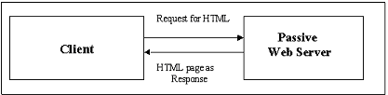

An active Web Server generates dynamic Web Pages

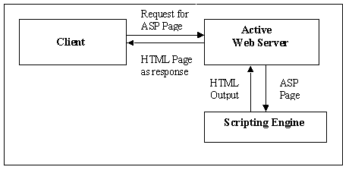
- ASP.NET Web Forms provide an easy and powerful way to build dynamic Web UI.
- ASP.NET Web Forms pages can target any browser client (there are no script library or cookie requirements).
- ASP.NET Web Forms pages provide syntax compatibility with existing ASP pages.
- ASP.NET server controls provide an easy way to encapsulate common functionality.
- ASP.NET ships with 45 built-in server controls. Developers can also use controls built by third parties.
- ASP.NET server controls can automatically project both up level and down level HTML.
- ASP.NET templates provide an easy way to customize the look and feel of list server controls.
- ASP.NET validation controls provide an easy way to do declarative client or server data validation.

C#.NET

ADO.NET OVERVIEW

ADO.NET is an evolution of the ADO data access model that directly addresses user requirements for developing scalable applications. It was designed specifically for the web with scalability, statelessness, and XML in mind.
ADO.NET uses some ADO objects, such as the Connection and Command objects, and also introduces new objects. Key new ADO.NET objects include the DataSet, DataReader, and DataAdapter.
The following sections will introduce you to some objects that have evolved, and some that are new. These objects are:

- Connections. For connection to and managing transactions against a database.
- Commands. For issuing SQL commands against a database.
- DataReaders. For reading a forward-only stream of data records from a SQL Server data source.
- DataSets. For storing, Remoting and programming against flat data, XML data and relational data.
- DataAdapters. For pushing data into a DataSet, and reconciling data against a database.
When dealing with connections to a database, there are two different options: SQL Server .NET Data Provider (System.Data.SqlClient) and OLE DB .NET Data Provider (System.Data.OleDb). In these samples we will use the SQL Server .NET Data Provider. These are written to talk directly to Microsoft SQL Server. The OLE DB .NET Data Provider is used to talk to any OLE DB provider (as it uses OLE DB underneath).

Connections:
Connections are used to 'talk to' databases, and are represented by provider-specific classes such as SqlConnection. Commands travel over connections and resultsets are returned in the form of streams which can be read by a DataReader object, or pushed into a DataSet object.

Commands:
Commands contain the information that is submitted to a database, and are represented by provider-specific classes such as SqlCommand. A command can be a stored procedure call, an UPDATE statement, or a statement that returns results. You can also use input and output parameters, and return values as part of your command syntax. The example below shows how to issue an INSERT statement against the Northwind database.

DataReaders:
The DataReader object is somewhat synonymous with a read-only/forward-only cursor over data. The DataReader API supports flat as well as hierarchical data. A DataReader object is returned after executing a command against a database. The format of the returned DataReader object is different from a recordset. For example, you might use the DataReader to show the results of a search list in a web page.

DATASETS AND DATAADAPTERS:
DataSets
The DataSet object is similar to the ADO Recordset object, but more powerful, and with one other important distinction: the DataSet is always disconnected. The DataSet object represents a cache of data, with database-like structures such as tables, columns, relationships, and constraints. However, though a DataSet can and does behave much like a database, it is important to remember that DataSet objects do not interact directly with databases, or other source data. This allows the developer to work with a programming model that is always consistent, regardless of where the source data resides. Data coming from a database, an XML file, from code, or user input can all be placed into DataSet objects. Then, as changes are made to the DataSet they can be tracked and verified before updating the source data. The GetChanges method of the DataSet object actually creates a second DatSet that contains only the changes to the data. This DataSet is then used by a DataAdapter (or other objects) to update the original data source.
The DataSet has many XML characteristics, including the ability to produce and consume XML data and XML schemas. XML schemas can be used to describe schemas interchanged via WebServices. In fact, a DataSet with a schema can actually be compiled for type safety and statement completion.

DATAADAPTERS (OLEDB/SQL)

The DataAdapter object works as a bridge between the DataSet and the source data. Using the provider-specific SqlDataAdapter (along with its associated SqlCommand and SqlConnection) can increase overall performance when working with a Microsoft SQL Server databases. For other OLE DB-supported databases, you would use the OleDbDataAdapter object and its associated OleDbCommand and OleDbConnection objects.

ADO.NET follows the below process, below Figure, to connect to the database and retrieve data to the application.

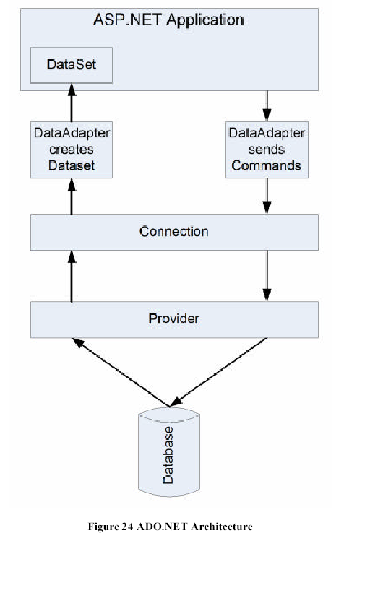
SQL SERVER

A database management, or DBMS, gives the user access to their data and helps them transform the data into information. Such database management systems include dBase, paradox, IMS, SQL Server and SQL Server. These systems allow users to create, update and extract information from their database.
A database is a structured collection of data. Data refers to the characteristics of people, things and events. SQL Server stores each data item in its own fields. In SQL Server, the fields relating to a particular person, thing or event are bundled together to form a single complete unit of data, called a record (it can also be referred to as raw or an occurrence). Each record is made up of a number of fields. No two fields in a record can have the same field name.
During an SQL Server Database design project, the analysis of your business needs identifies all the fields or attributes of interest. If your business needs change over time, you define any additional fields or change the definition of existing fields.

SQL SERVER TABLES
SQL Server stores records relating to each other in a table. Different tables are created for the various groups of information. Related tables are grouped together to form a database.

PRIMARY KEY
Every table in SQL Server has a field or a combination of fields that uniquely identifies each record in the table. The Unique identifier is called the Primary Key, or simply the Key. The primary key provides the means to distinguish one record from all other in a table. It allows the user and the database system to identify, locate and refer to one particular record in the database.

RELATIONAL DATABASE
Sometimes all the information of interest to a business operation can be stored in one table. SQL Server makes it very easy to link the data in multiple tables. Matching an employee to the department in which they work is one example. This is what makes SQL Server a relational database management system, or RDBMS. It stores data in two or more tables and enables you to define relationships between the table and enables you to define relationships between the tables.

FOREIGN KEY
When a field is one table matches the primary key of another field is referred to as a foreign key. A foreign key is a field or a group of fields in one table whose values match those of the primary key of another table.

REFERENTIAL INTEGRITY
Not only does SQL Server allow you to link multiple tables, it also maintains consistency between them. Ensuring that the data among related tables is correctly matched is referred to as maintaining referential integrity.

DATA ABSTRACTION
A major purpose of a database system is to provide users with an abstract view of the data. This system hides certain details of how the data is stored and maintained. Data abstraction is divided into three levels.

Physical level: This is the lowest level of abstraction at which one describes how the data are actually stored.

Conceptual Level: At this level of database abstraction all the attributed and what data are actually stored is described and entries and relationship among them.

View level: This is the highest level of abstraction at which one describes only part of the database.

ADVANTAGES OF RDBMS

- Redundancy can be avoided
- Inconsistency can be eliminated
- Data can be Shared
- Standards can be enforced
- Security restrictions ca be applied
- Integrity can be maintained
- Conflicting requirements can be balanced
- Data independence can be achieved.

DISADVANTAGES OF DBMS
A significant disadvantage of the DBMS system is cost. In addition to the cost of purchasing of developing the software, the hardware has to be upgraded to allow for the extensive programs and the workspace required for their execution and storage. While centralization reduces duplication, the lack of duplication requires that the database be adequately backed up so that in case of failure the data can be recovered.

Chapter 6
SYSTEM DESIGN

6.1. INTRODUCTION

Software design sits at the technical kernel of the software engineering process and is applied regardless of the development paradigm and area of application. Design is the first step in the development phase for any engineered product or system. The designer’s goal is to produce a model or representation of an entity that will later be built. Beginning, once system requirement have been specified and analyzed, system design is the first of the three technical activities -design, code and test that is required to build and verify software.

6.2. SYSTEM WORKFLOW

(Logging Via Cust ID)
|
Product Search/ Listing
|
Selecting a Perticular Product
|
Selection through CheckBox ---------> Temp order record record *
|
Billing/ Shipping Info ----------> Recording Customer's Data
|
Shipping + Product Price Calculated ----> If shipped via 3rd party then charge is
| calculated from their linked server
Order Confirmation & Accept Order ----> Entry into main database including temp
| records. * Delete temp record
CCard/ PayPal/ Offline Pay Process
| | |
----------- ----------- ----------
ViaEmail ViaEmail ViaEmail
----------- ----------- ----------
| | |
Invoice to Seller Charge
Customer Invoice Amount
( in case of
3rd party
seller as Ebay)

6.3. E – R DIAGRAMS
  - The relation upon the system is structure through a conceptual ER-Diagram, which not only specifics the existential entities but also the standard relations through which the system exists and the cardinalities that are necessary for the system state to continue.
  - The entity Relationship Diagram (ERD) depicts the relationship between the data objects. The ERD is the notation that is used to conduct the date modeling activity the attributes of each data object noted is the ERD can be described resign a data object descriptions.
  - The set of primary components that are identified by the ERD are
◆ Data object  Relationships
◆ Attributes  Various types of indicators.
The primary purpose of the ERD is to represent data objects and their relationships.

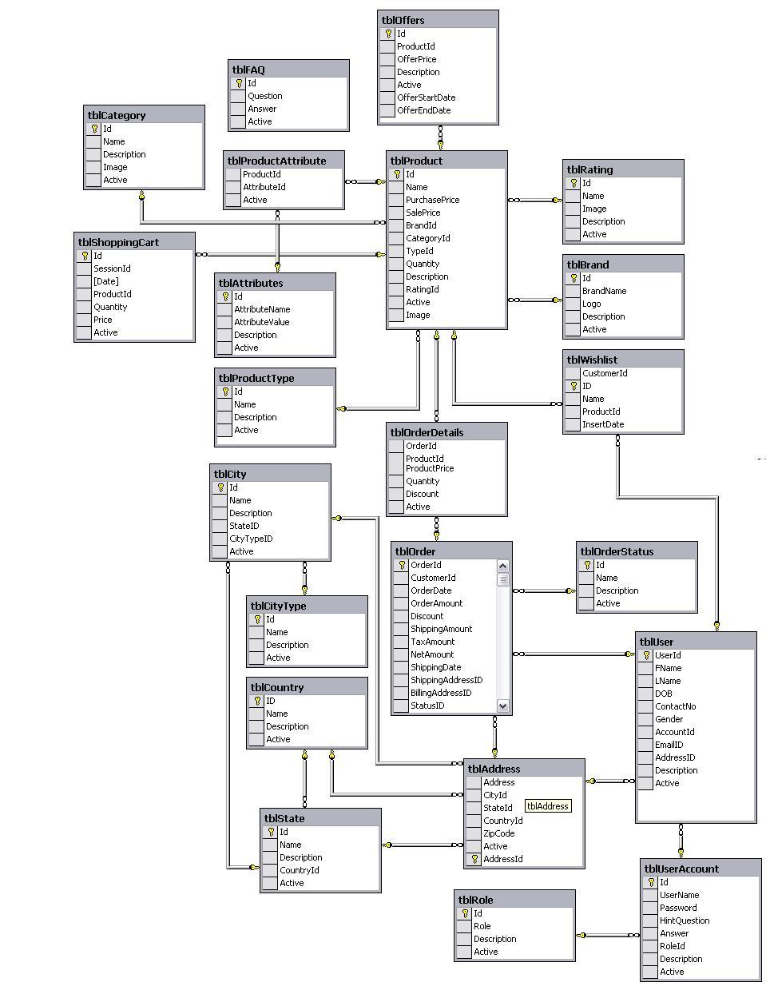

6.4. DATA FLOW DIAGRAMS

DATA FLOW DIAGRAMS
A data flow diagram is graphical tool used to describe and analyze movement of data through a system. These are the central tool and the basis from which the other components are developed. The transformation of data from input to output, through processed, may be described logically and independently of physical components associated with the system. These are known as the logical data flow diagrams. The physical data flow diagrams show the actual implements and movement of data between people, departments and workstations. A full description of a system actually consists of a set of data flow diagrams.
DFD SYMBOLS:
In the DFD, there are four symbols
- A square defines a source(originator) or destination of system data
- An arrow identifies data flow. It is the pipeline through which the information flows
- A circle or a bubble represents a process that transforms incoming data flow into outgoing data flows.
- An open rectangle is a data store, data at rest or a temporary repository of data

Process that transforms data flow.

Source or Destination of data
Data flow

Data Store

RULES GOVERNING THE DFD’S

PROCESS
- No process can have only outputs.
- No process can have only inputs. If an object has only inputs than it must be a sink.
- A process has a verb phrase label.

DATA STORE
- Data cannot move directly from one data store to another data store, a process must move data.
- Data cannot move directly from an outside source to a data store, a process, which receives, must move data from the source and place the data into data store
- A data store has a noun phrase label.

SOURCE OR SINK
The origin and /or destination of data.

- Data cannot move direly from a source to sink it must be moved by a process
- A source and /or sink has a noun phrase land

DATA FLOW
- A Data Flow has only one direction of flow between symbols. It may flow in both directions between a process and a data store to show a read before an update. The later is usually indicated however by two separate arrows since these happen at different type.
- A join in DFD means that exactly the same data comes from any of two or more different processes data store or sink to a common location.
- A data flow cannot go directly back to the same process it leads. There must be at least one other process that handles the data flow produce some other data flow returns the original data into the beginning process.
- A Data flow to a data store means update (delete or change).
- A data Flow from a data store means retrieve or use.

A data flow has a noun phrase label more than one data flow noun phrase can appear on a single arrow as long as all of the flows on the same arrow move together as one package.

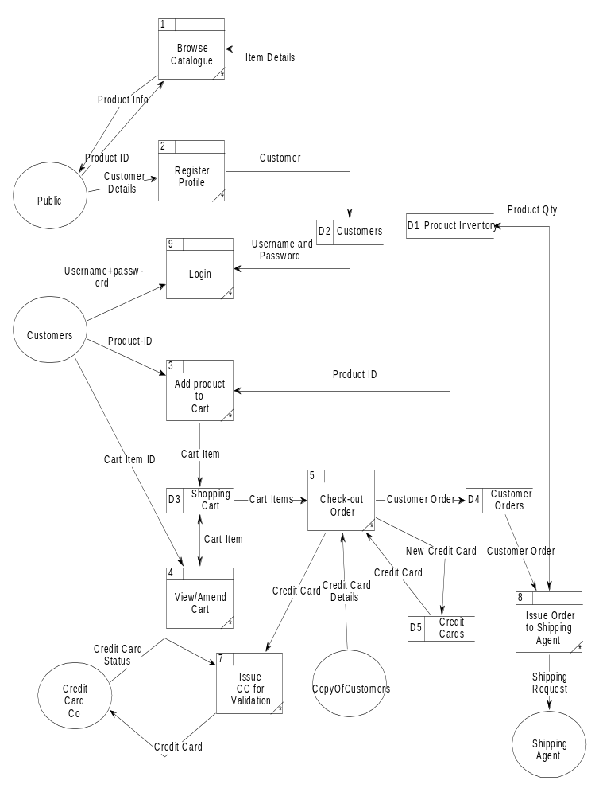
Unified Modeling Language Diagrams
  - The unified modeling language allows the software engineer to express an analysis model using the modeling notation that is governed by a set of syntactic semantic and pragmatic rules.
  - A UML system is represented using five different views that describe the system from distinctly different perspective. Each view is defined by a set of diagram, which is as follows.
  - User Model View
    - This view represents the system from the users perspective.
    - The analysis representation describes a usage scenario from the end-users perspective.
  - Structural model view
◆ In this model the data and functionality are arrived from inside the system.
◆ This model view models the static structures.
  - Behavioral Model View
◆ It represents the dynamic of behavioral as parts of the system, depicting the interactions of collection between various structural elements described in the user model and structural model view.
  - Implementation Model View
  - In this the structural and behavioral as parts of the system are represented as they are to be built.
Environmental Model View
In this the structural and behavioral aspects of the environment in which the system is to be implemented are represented.

UML is specifically constructed through two different domains they are
  - UML Analysis modeling, which focuses on the user model and structural model views of the system
  - UML design modeling, which focuses on the behavioral modeling, implementation modeling and environmental model views.
UML DIAGRAMS
Every complex system is best approached through a small set of nearly independent views of a model; no single viewer is sufficient. Every model may be expressed at different levels of fidelity. The best models are connected to reality. The UML defines nine graphical diagrams.
- Class diagram
- Object diagram
- Use-case diagram
- Behavior diagrams
Interaction diagram
Sequence diagram
Collaboration diagram
4.2. Activity diagram

USE CASE DESIGN:
Admin
ONLINE ELECTRONIC SHOP Web Portal
Category Management
Product Management
Content Management
Order Management
Purchase Module
Customer
<<extend>>

<<extend>>

<<extend>>

<<extend>>

<<extend>>

Customer Management

Category Management
View Category
Add Category
Update Category
Admin
Customer

Customer Management
View Customer Details
List Customer
Add Customer
Update Customer
Delete Customer
Admin
Customer

Content Management
View Content Page
Update Content Page
Admin
Customer

Catalog Management
Admin
Customer
Manage Country
View Country
Add Country
Update Country
<<extend>>
<<extend>>
<<extend>>
Manage State
View State
Add State
Update State
<<extend>>
<<extend>>
<<extend>>
Manage City
View City
Add City
Update City
<<extend>>
<<extend>>
<<extend>>

Use Case Sequence Diagrams
CUSTOMER
CATEGORY MANAGER
CATEGORIES
View Categories Request
Search Categories
Categories List
Result

(Fig 1.1) – Searching Categories

CUSTOMER
PRODUCT MANAGER
PRODUCTS
View Products Request
Search Products
Products List
Result

(Fig 1.2) – Searching Products List

USER
CUSTOMER MANAGER
CUSTOMERS
Personal, Address & credential details
Register User
Customer Registration Status
Result

Fig. 1.3 – User Registration

Customer
Login
Product manager
Products
Shopping Cart
Payment Gateway
Orders
Click on Login Button
Click on Product Link
Search for Product
Click on Add to Cart
Click on Billing
Select the Payment Mode
Check the Status of Order
Return to Customer Home Page

Fig. 1.4 – Product Purchase Process

Admin
Order Manager
Orders
Login Details
Manage Orders
Status
Result
Login Screen
Order Details
Result

Fig. 1.5 – Order Management

6.5. DATA DICTONARY
After carefully understanding the requirements of the client the the entire data storage requirements are divided into tables. The below tables are normalized to avoid any anomalies during the course of data entry.

Table: tblAddress
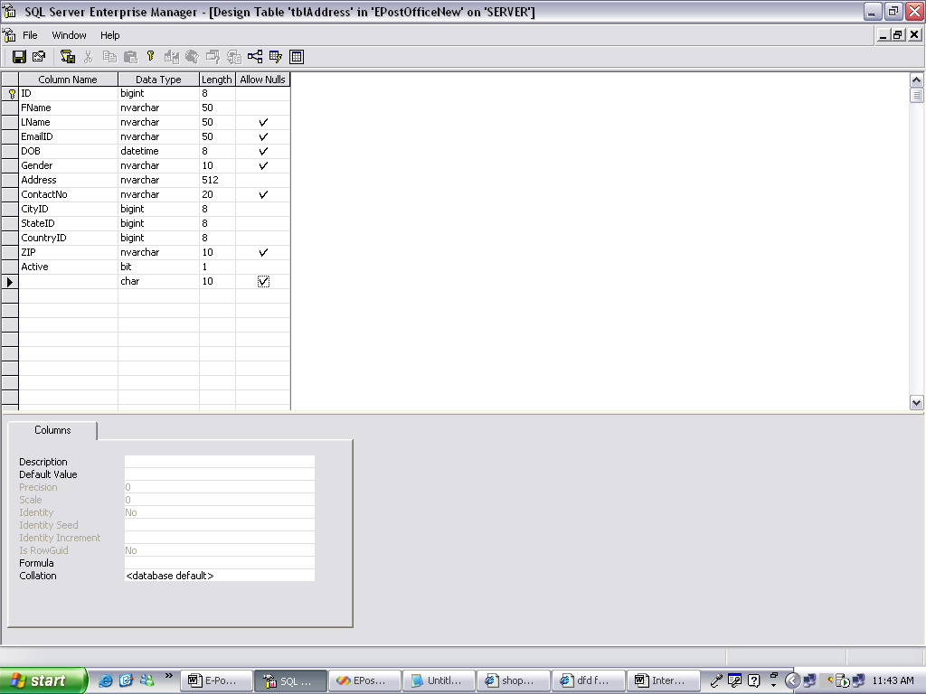

Table: tblAdminMenu
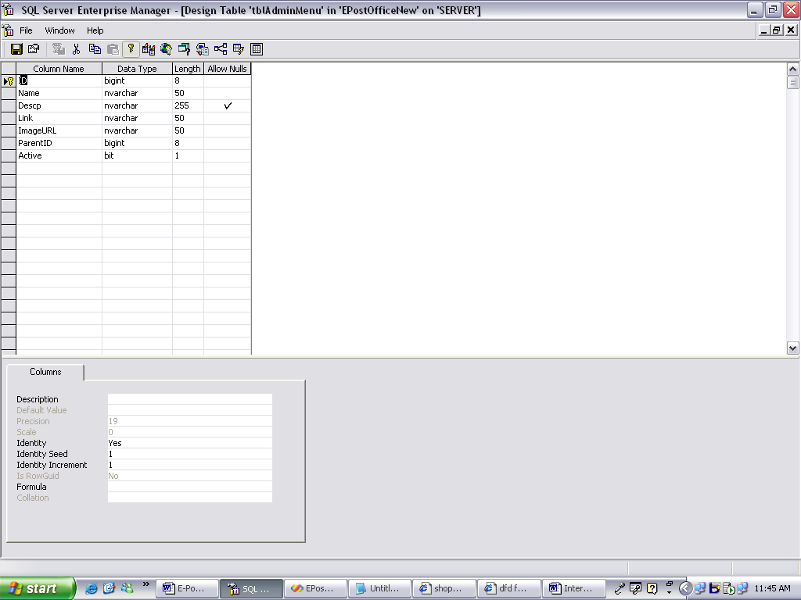

Table:tblAdminMenu

Table: tblAttributes
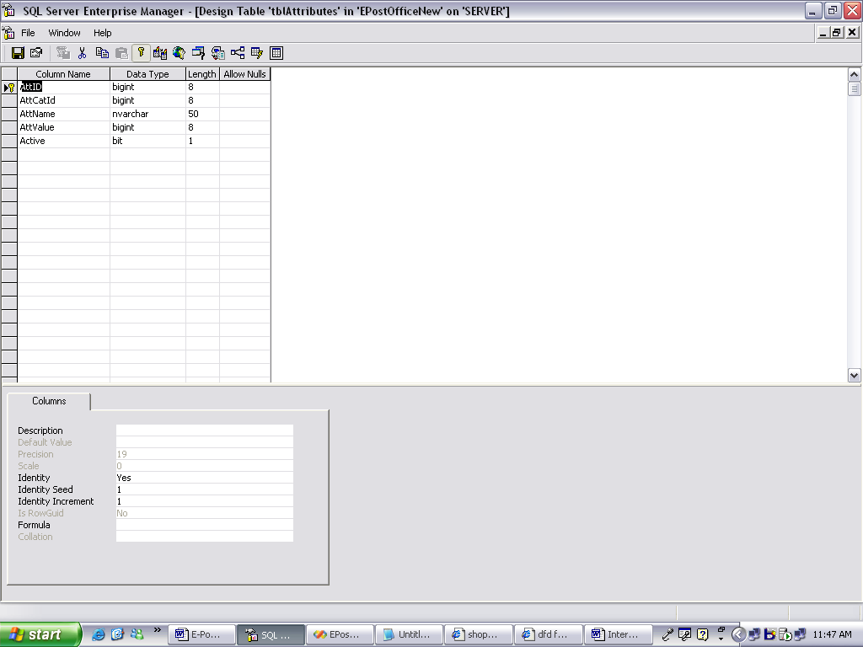
Table: tblBrands
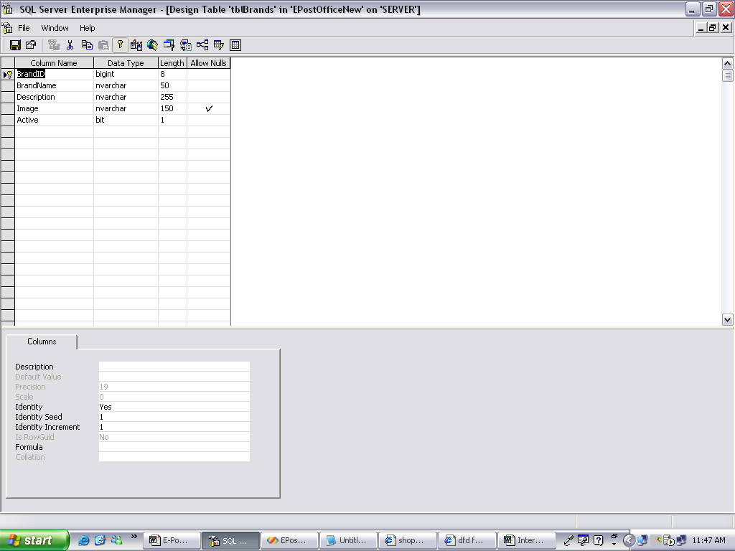

Table: tblCategories
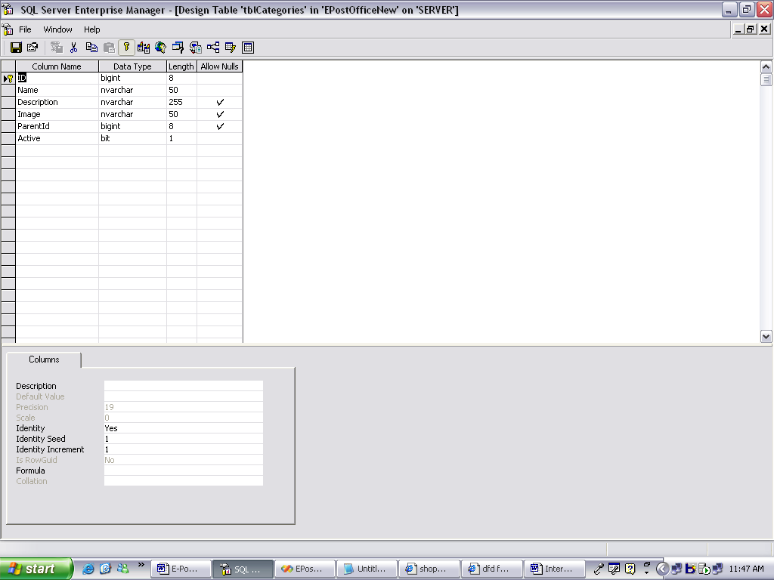

Table: tblCity
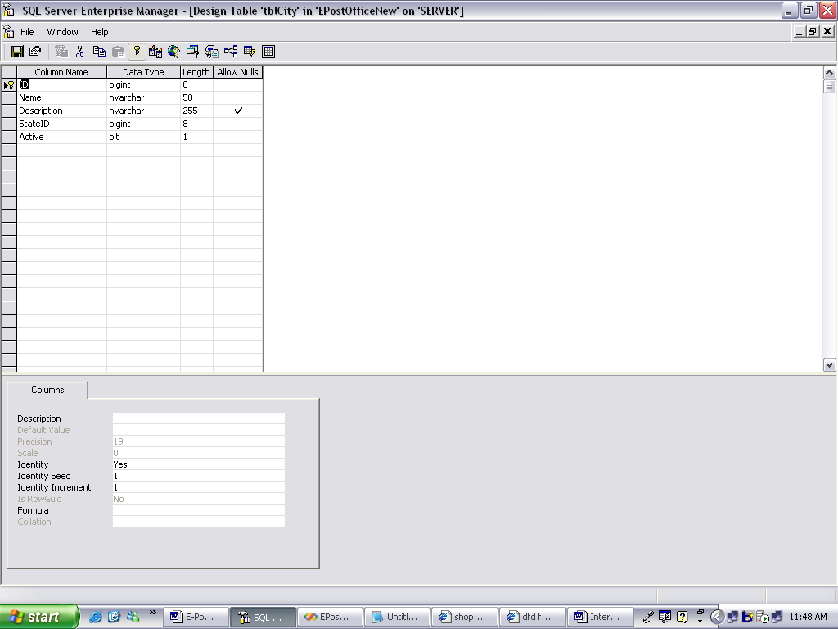

Table:tblCountry
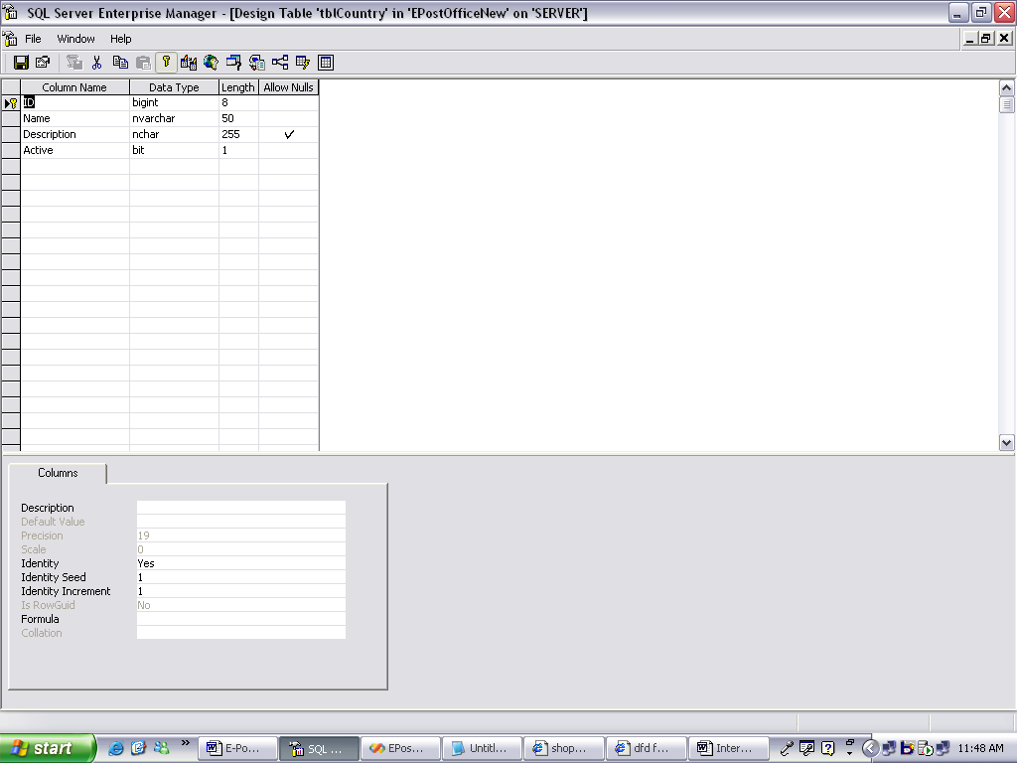

Table:tblCustomer
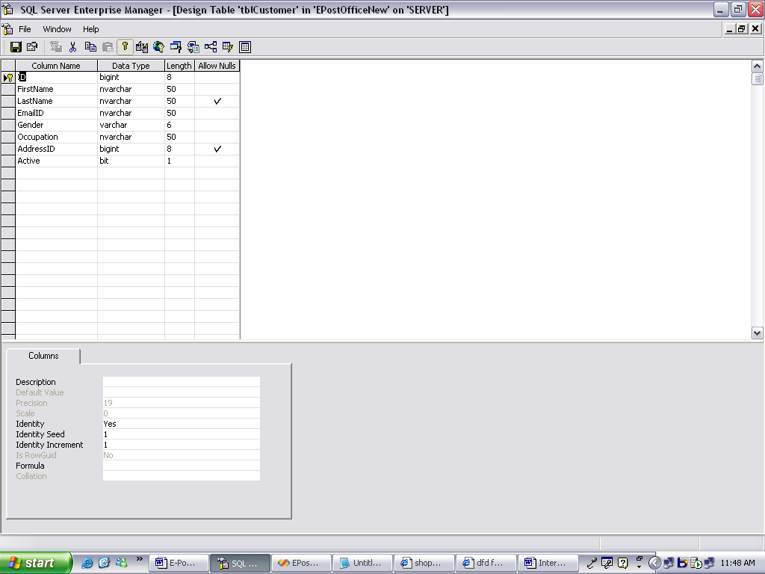

Table: tblFeaturedProducts
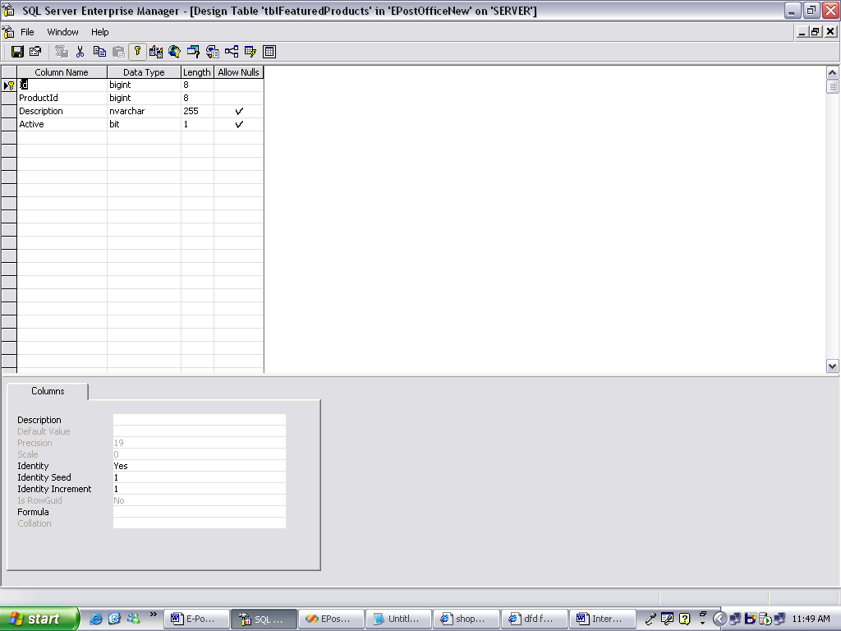
Table: tblHintQuestion
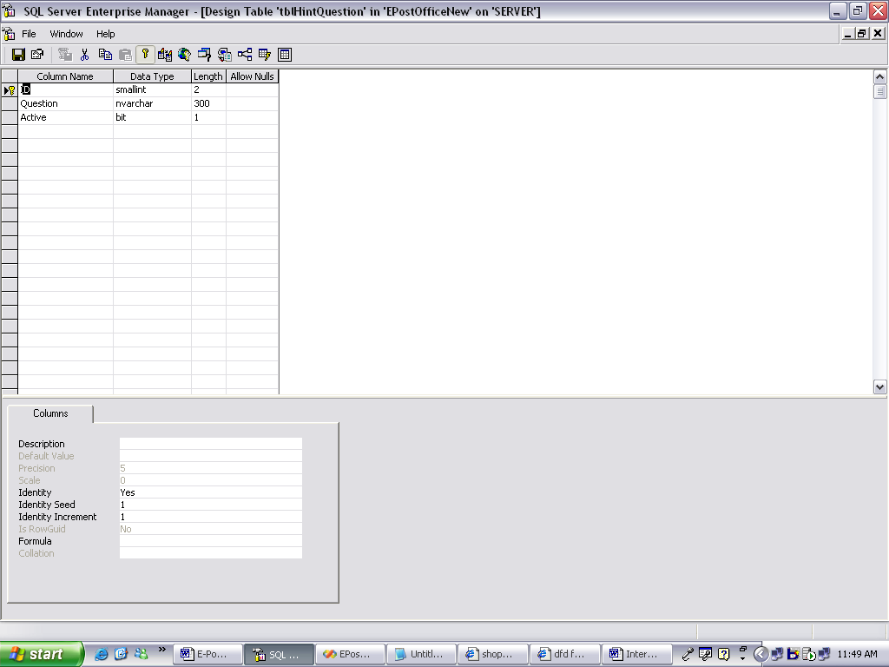

Table: tblHotSellingProducts
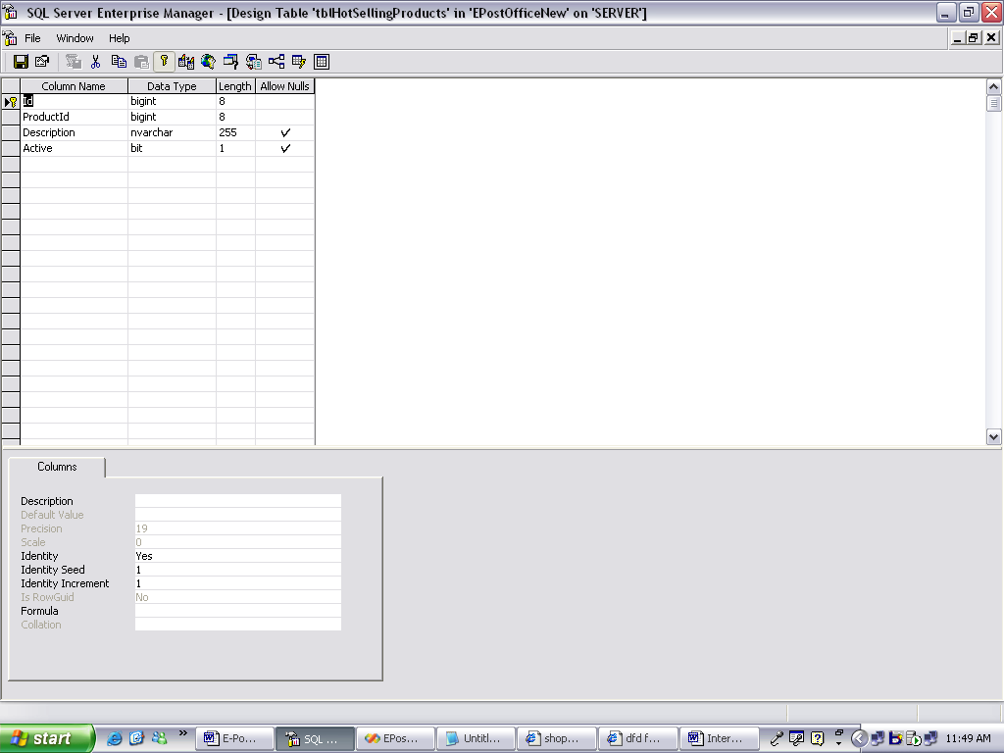
Table: tblNewlyAddedProducts
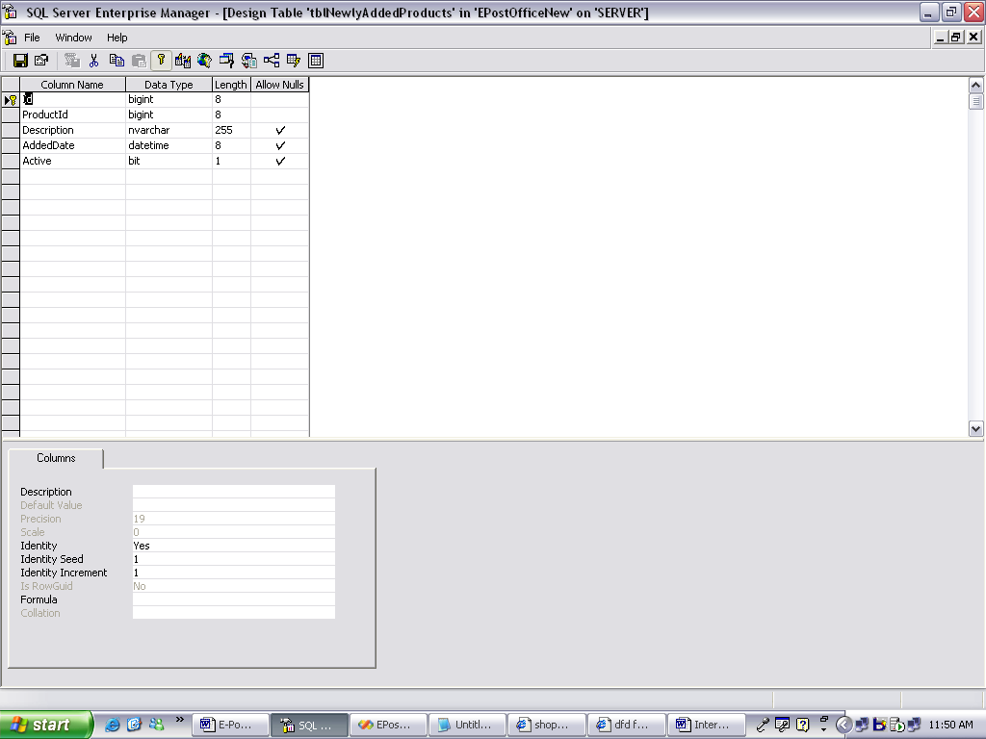

Table: tblOfferedProducts
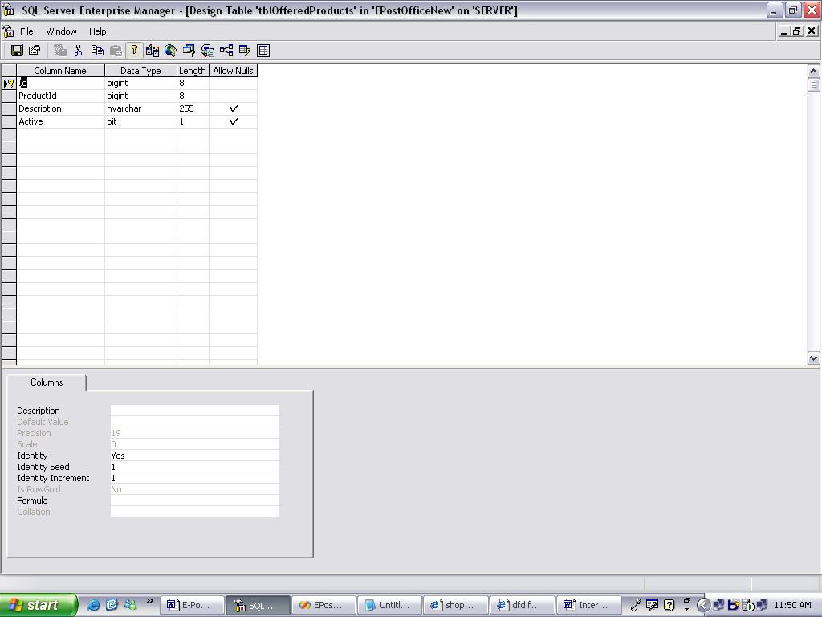
Table: tblOrderDetails
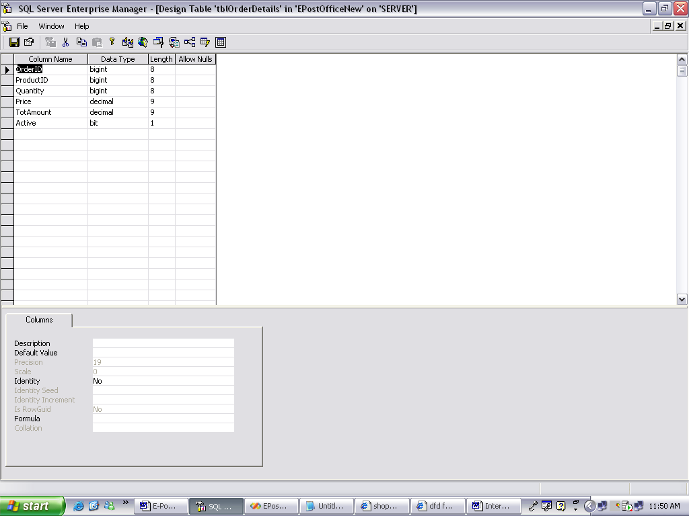

Table: tblOrders
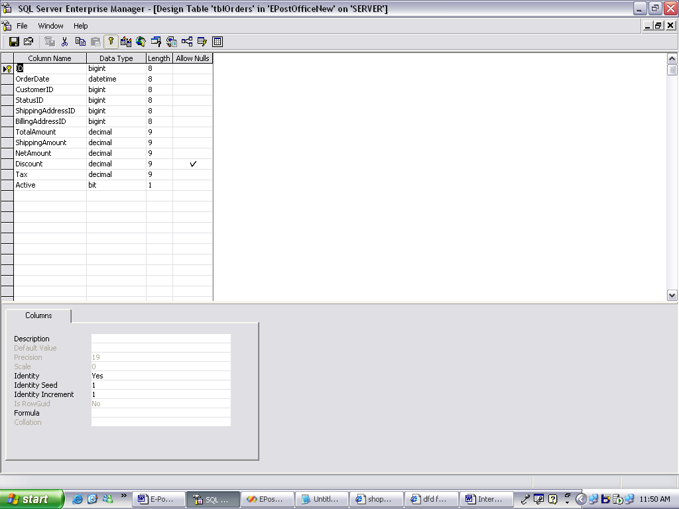
Table: tblOrderStatus
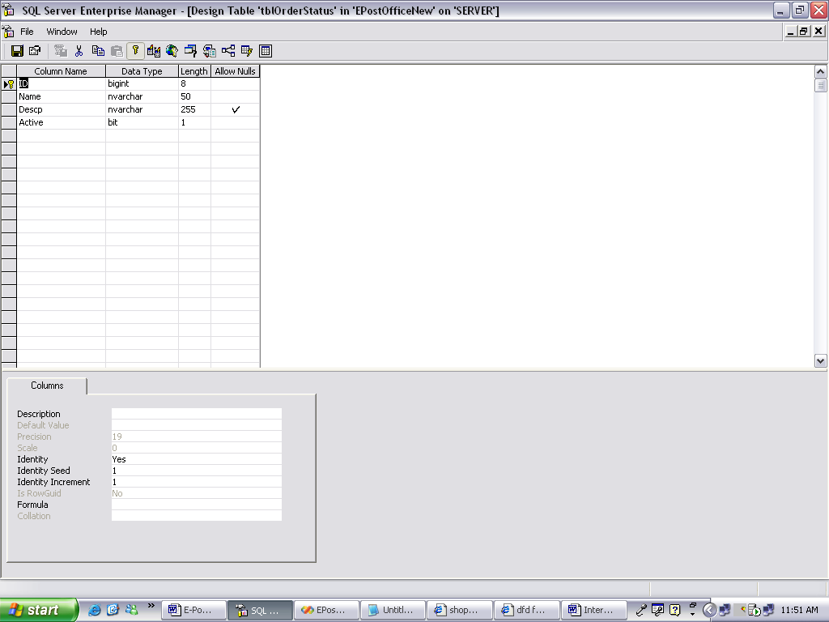

Table: tblPageContent
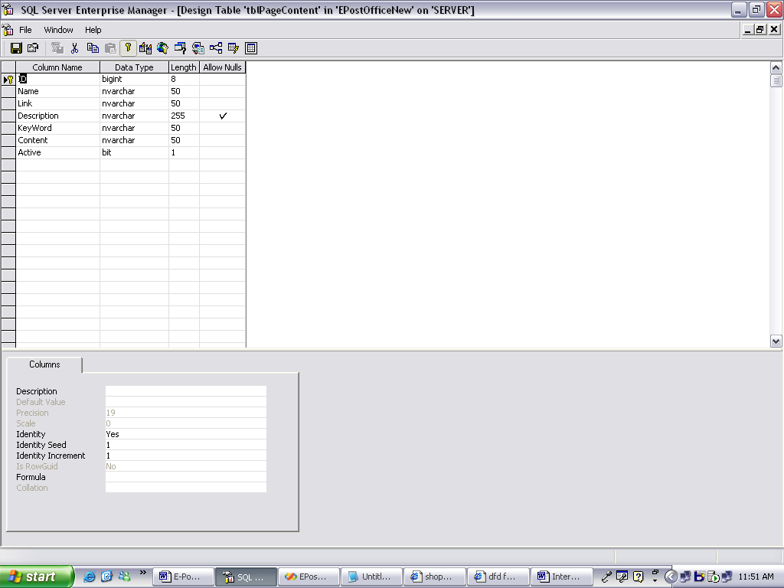
Table: tblPostageCalculator
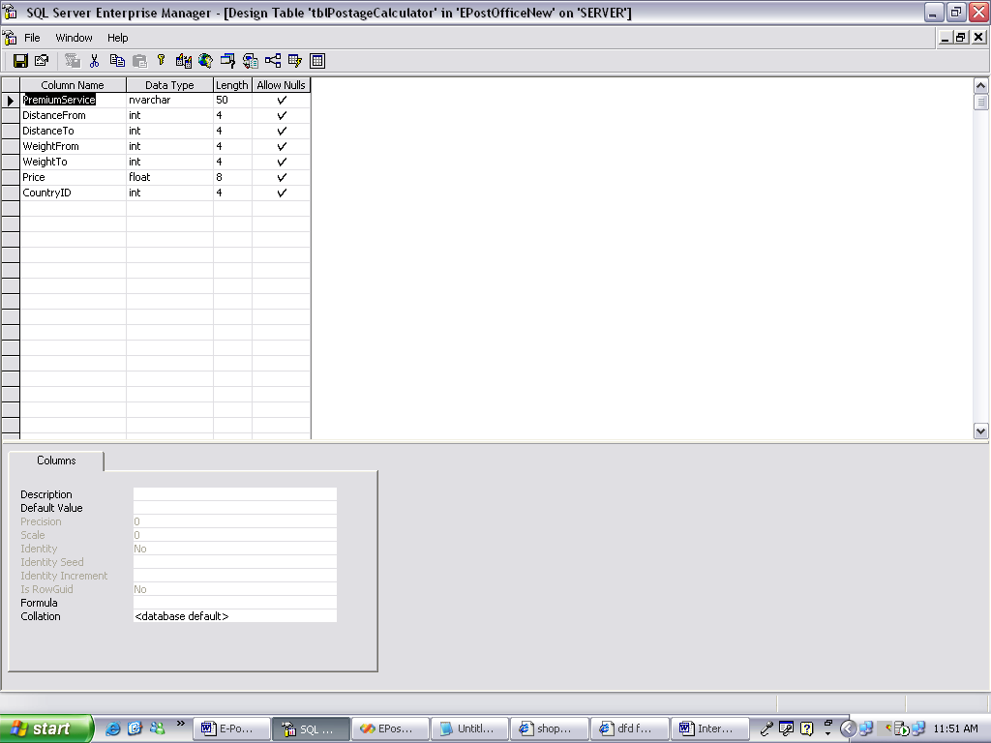
Table: tblProductsAdditionalPrice
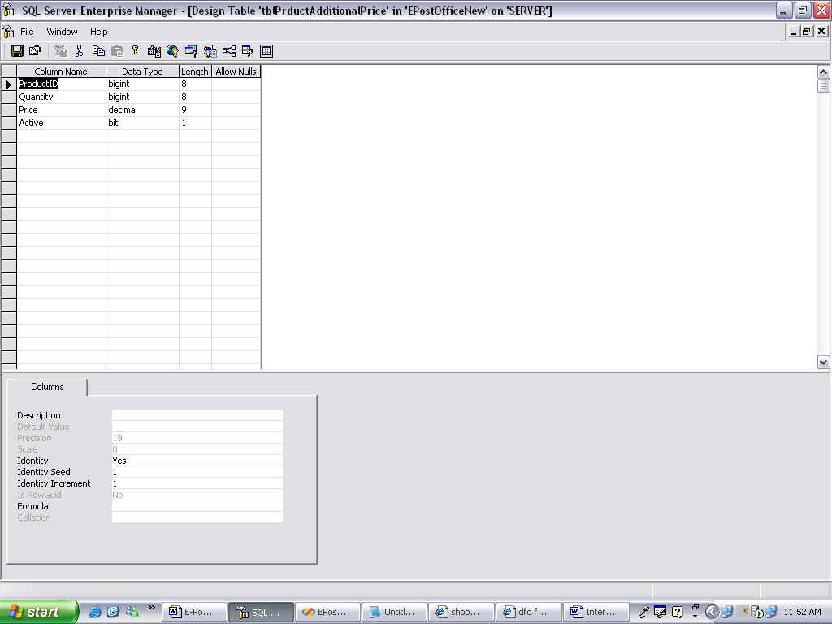
Table: tblProducts
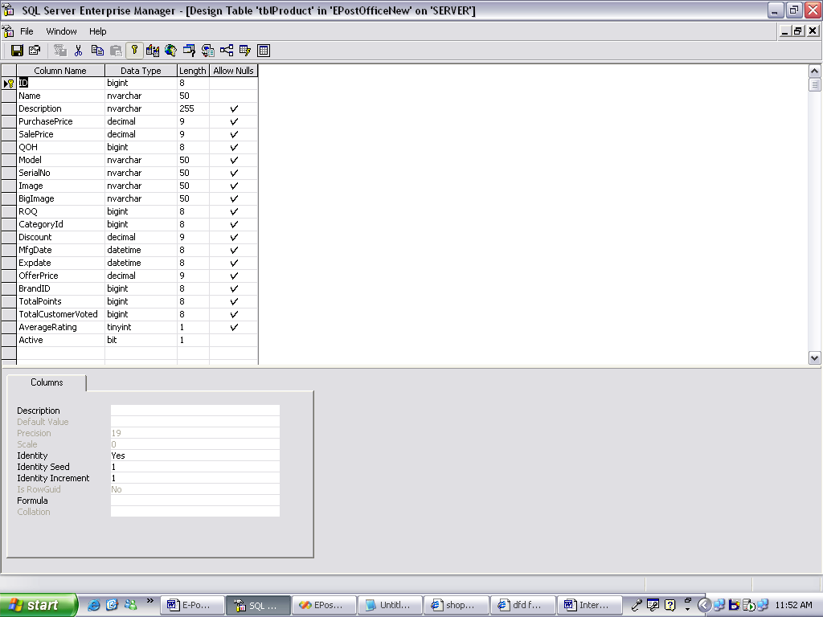
Table: tblProductAttribute
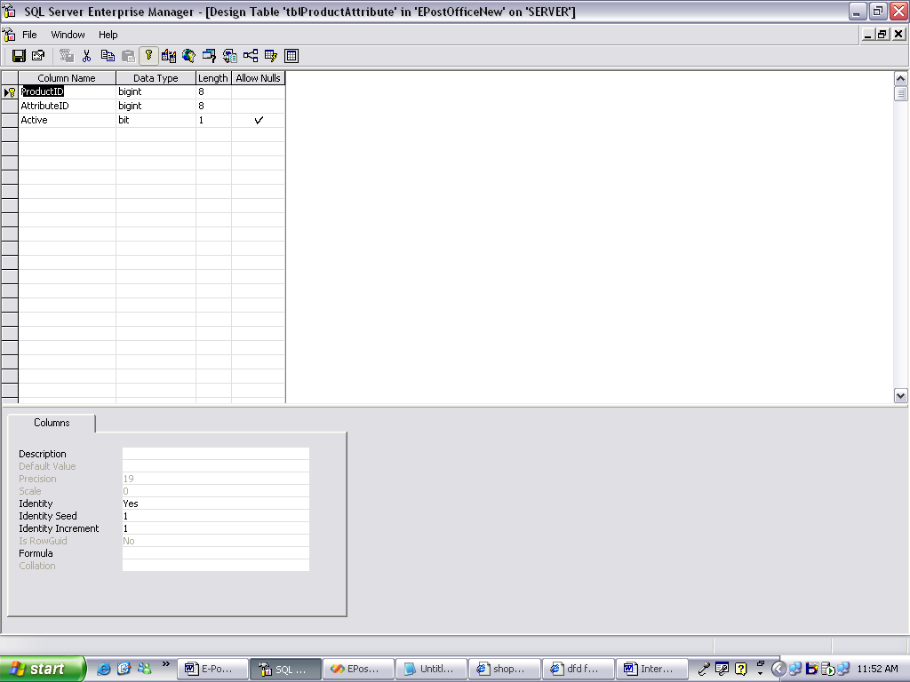
Table: tblProductImages
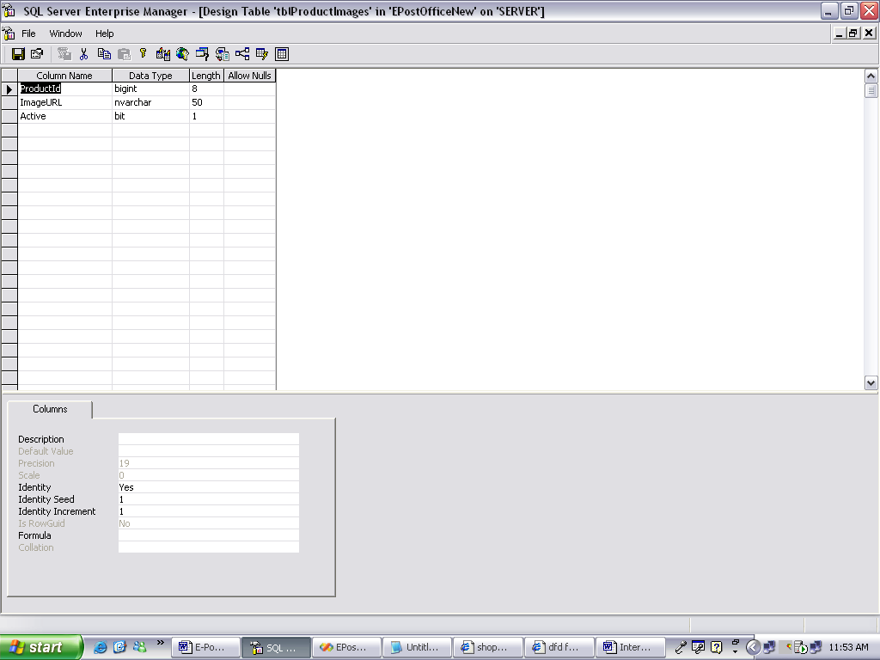

Table: tblProductRating
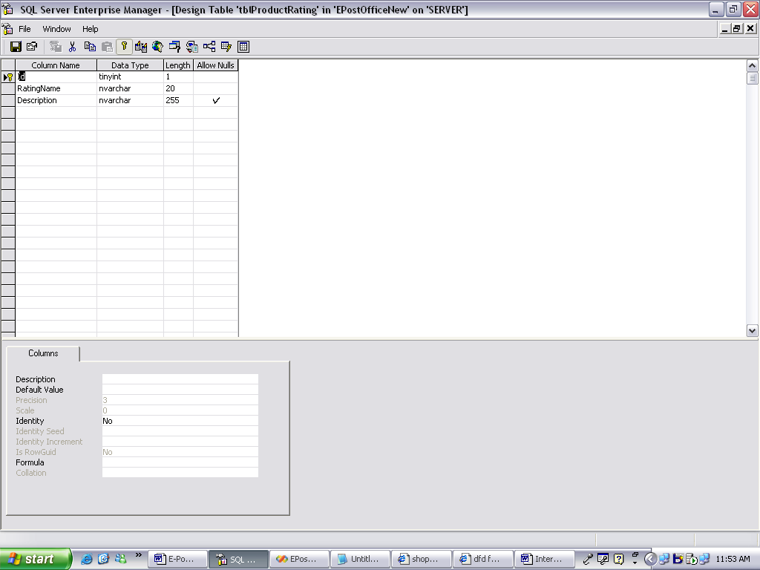
Table: tblShoppingCart
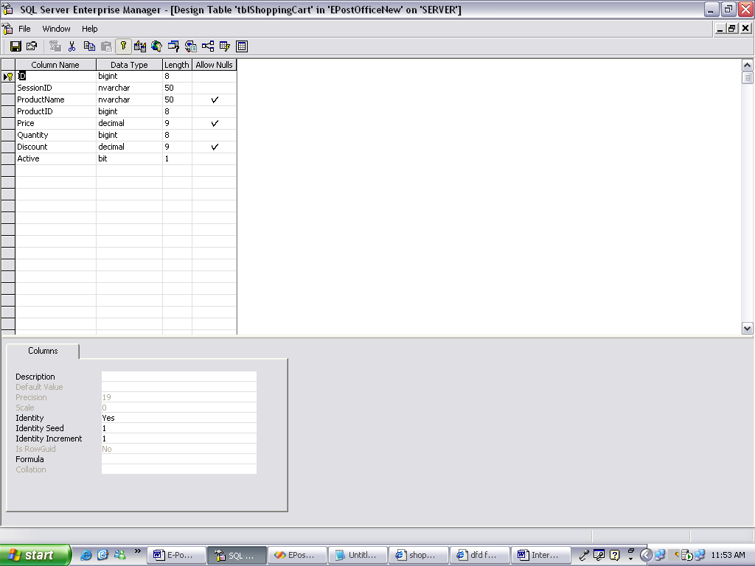

Table: tblState
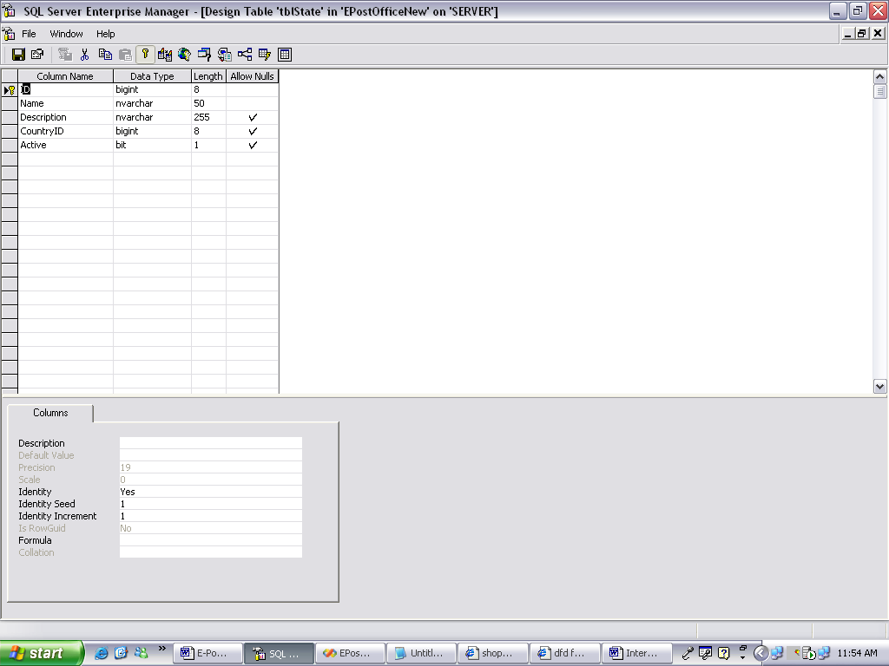
Table: tblUpComingProducts
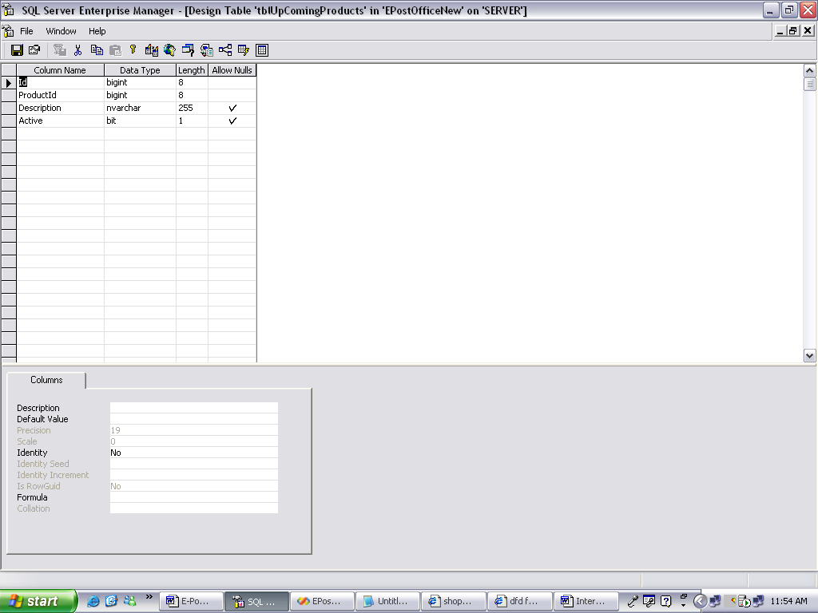

Table:tblUser
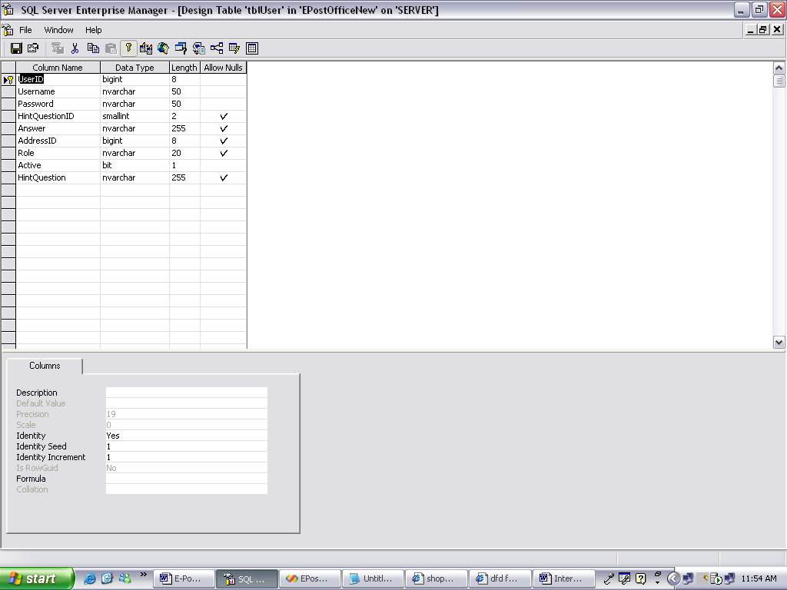

Table:tblWishList
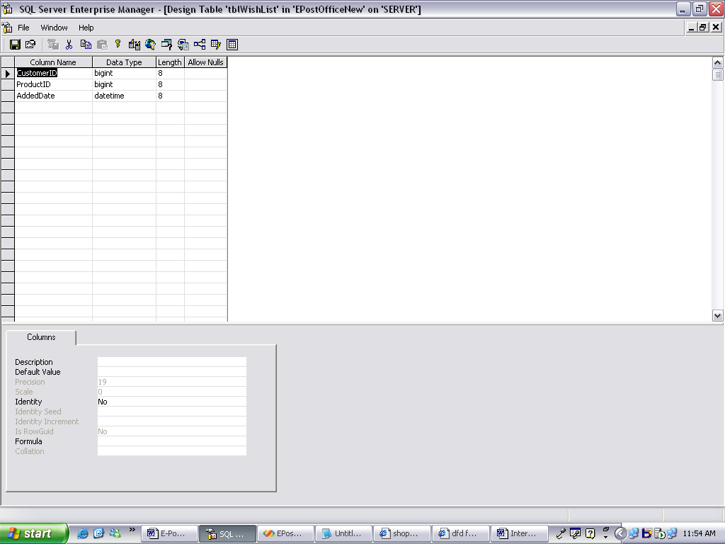

Chapter 7
OUTPUT SCREENS

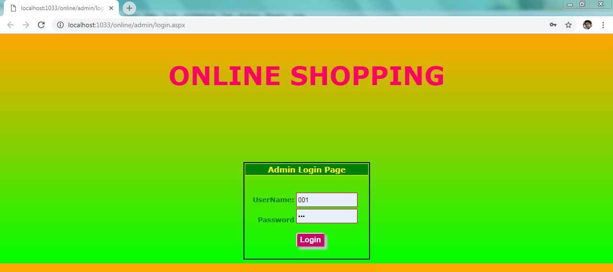
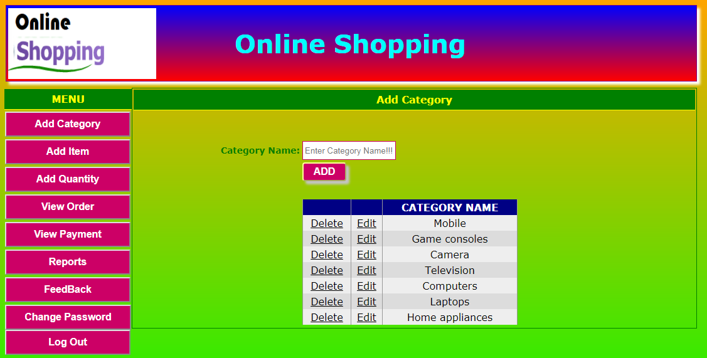

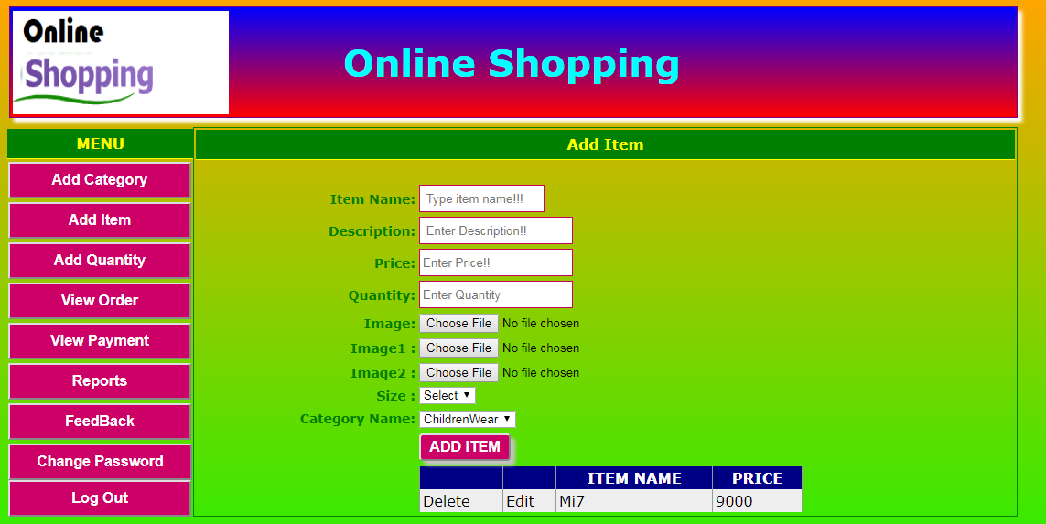
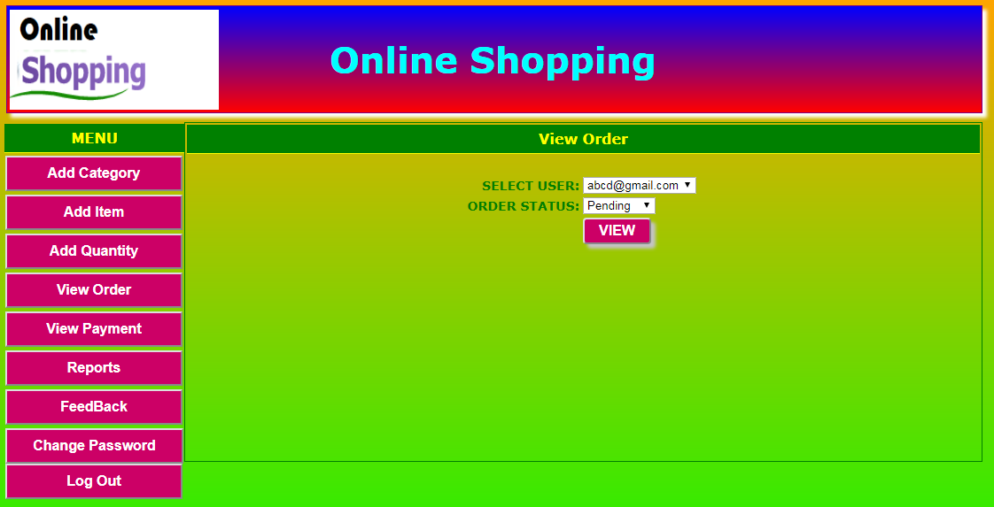

Chapter 8
SYSTEM TESTING AND IMPLEMENTATION

8.1. INTRODUCTION
Software testing is a critical element of software quality assurance and represents the ultimate review of specification, design and coding. In fact, testing is the one step in the software engineering process that could be viewed as destructive rather than constructive.
8.2. STRATEGIC APPROACH TO SOFTWARE TESTING
The software engineering process can be viewed as a spiral. Initially system engineering defines the role of software and leads to software requirement analysis where the information domain, functions, behavior, performance, constraints and validation criteria for software are established. Moving inward along the spiral, we come to design and finally to coding. To develop computer software we spiral in along streamlines that decrease the level of abstraction on each turn.

A strategy for software testing may also be viewed in the context of the spiral. Unit testing begins at the vertex of the spiral and concentrates on each unit of the software as implemented in source code. Testing progress by moving outward along the spiral to integration testing, where the focus is on the design and the construction of the software architecture. Talking another turn on outward on the spiral we encounter validation testing where requirements established as part of software requirements analysis are validated against the software that has been constructed. Finally we arrive at system testing, where the software and other system elements are tested as a whole.

UNIT TESTING

MODULE TESTING

SUB-SYSTEM TESING

SYSTEM TESTING

ACCEPTANCE TESTING
Component Testing
Integration Testing
User Testing

8.3. Unit Testing
Unit testing focuses verification effort on the smallest unit of software design, the module. The unit testing we have is white box oriented and some modules the steps are conducted in parallel.
1. WHITE BOX TESTING
This type of testing ensures that
- All independent paths have been exercised at least once
- All logical decisions have been exercised on their true and false sides
- All loops are executed at their boundaries and within their operational bounds
- All internal data structures have been exercised to assure their validity.

To follow the concept of white box testing we have tested each form .we have created independently to verify that Data flow is correct, All conditions are exercised to check their validity, All loops are executed on their boundaries.

2. BASIC PATH TESTING
Established technique of flow graph with Cyclomatic complexity was used to derive test cases for all the functions. The main steps in deriving test cases were:
Use the design of the code and draw correspondent flow graph.
Determine the Cyclomatic complexity of resultant flow graph, using formula:

V(G)=E-N+2 or
V(G)=P+1 or
V(G)=Number Of Regions

Where V(G) is Cyclomatic complexity,
E is the number of edges,
N is the number of flow graph nodes,
P is the number of predicate nodes.
Determine the basis of set of linearly independent paths.

3. CONDITIONAL TESTING
In this part of the testing each of the conditions were tested to both true and false aspects. And all the resulting paths were tested. So that each path that may be generate on particular condition is traced to uncover any possible errors.

4. DATA FLOW TESTING
This type of testing selects the path of the program according to the location of definition and use of variables. This kind of testing was used only when some local variable were declared. The definition-use chain method was used in this type of testing. These were particularly useful in nested statements.
5. LOOP TESTING
In this type of testing all the loops are tested to all the limits possible. The following exercise was adopted for all loops:
- All the loops were tested at their limits, just above them and just below them.
- All the loops were skipped at least once.
- For nested loops test the inner most loop first and then work outwards.
- For concatenated loops the values of dependent loops were set with the help of connected loop.
- Unstructured loops were resolved into nested loops or concatenated loops and tested as above.

Each unit has been separately tested by the development team itself and all the input have been validated.

Chapter 9
System Security

9.1. Introduction
The protection of computer based resources that includes hardware, software, data, procedures and people against unauthorized use or natural
Disaster is known as System Security.

System Security can be divided into four related issues:
- Security
- Integrity
- Privacy
- Confidentiality

SYSTEM SECURITY refers to the technical innovations and procedures applied to the hardware and operation systems to protect against deliberate or accidental damage from a defined threat.

DATA SECURITY is the protection of data from loss, disclosure, modification and destruction.

SYSTEM INTEGRITY refers to the power functioning of hardware and programs, appropriate physical security and safety against external threats such as eavesdropping and wiretapping.

PRIVACY defines the rights of the user or organizations to determine what information they are willing to share with or accept from others and how the organization can be protected against unwelcome, unfair or excessive dissemination of information about it.

CONFIDENTIALITY is a special status given to sensitive information in a database to minimize the possible invasion of privacy. It is an attribute of information that characterizes its need for protection.

9.2. SECURITY IN SOFTWARE

CLIENT SIDE VALIDATION
- VBScript in used to ensure those required fields are filled with suitable data only. Maximum lengths of the fields of the forms are appropriately defined.
- Forms cannot be submitted without filling up the mandatory data so that manual mistakes of submitting empty fields that are mandatory can be sorted out at the client side to save the server time and load.
- Tab-indexes are set according to the need and taking into account the ease of user while working with the system.

SERVER SIDE VALIDATION
- Server side constraint has been imposed to check for the validity of primary key and foreign key. A primary key value cannot be duplicated. Any attempt to duplicate the primary value results into a message intimating the user about those values through the forms using foreign key can be updated only of the existing foreign key values.
- User is intimating through appropriate messages about the successful operations or exceptions occurring at server side.
- Various Access Control Mechanisms have been built so that one user may not agitate upon another. Access permissions to various types of users are controlled according to the organizational structure. Only permitted users can log on to the system and can have access

Chapter 10

CONCLUSION

The Internet has become a major resource in modern business, thus electronic shopping has gained significance not only from the entrepreneur’s but also from the customer’s point of view. For the entrepreneur, electronic shopping generates new business opportunities and for the customer, it makes comparative shopping possible. As per a survey, most consumers of online stores are impulsive and usually make a decision to stay on a site within the first few seconds. “Website design is like a shop interior. If the shop looks poor or like hundreds of other shops the customer is most likely to skip to the other site. Hence we have designed the project to provide the user with easy navigation, retrieval of data and necessary feedback as much as possible.

In this project, the user is provided with an e-commerce web site that can be used to buy Products online. To implement this as a web application we used ASP.NET as the Technology. ASP.NET has several advantages such as enhanced performance, scalability, built- in security and simplicity. To build any web application using ASP.NET we need a programming language such as C#, VB.NET, J# and so on. C# was the language used to build this application. For the client browser to connect to the ASP.NET engine we used Microsoft’s Internet Information Services (IIS) as the Web Server.
It has been a great pleasure for me to work on this exciting and challenging project. This project proved good for me as it provided practical knowledge of not only programming in ASP.NET and C#.NET web based application and no some extent Windows Application and SQL Server, but also about all handling procedure related with “ONLINE ELECTRONIC SHOP”. It also provides knowledge about the latest technology used in developing web enabled application and client server technology that will be great demand in future. This will provide better opportunities and guidance in future in developing projects independently.

Chapter 11
FUTURE IMPROVEMENT

As for other future developments, the following can be done:
      - The Administrator of the web site can be given more functionality, like looking at a specific customer’s profile, the books that have to be reordered, etc.
      - Multiple Shopping carts can be allowed.
- A console for the data centre may be made available to allow the personnel to monitor on the sites which were cleared for hosting during a particular period.
- Moreover, it is just a beginning; further the system may be utilized in various other types of auditing operation viz. Network auditing or similar process/workflow based applications...

Chapter 12

BIBLIOGRAPHY

Books

1. Anderson, R., Francis, B., Homer, A., Howard, R., Sussman, D. and Watson.
(2001) Professional ASP.NET. Wrox Press Ltd.
2. Wagner, R., Daniels, K., Griffin, G., Haddad, C. and Nasr, J. (1997)
JavaScript Unleashed. SAMS Net.
3. Wiley, Y. M. J. & Sons. (1997) Creating the Virtual Store: Taking Your Web
Site from Browsing to Buying.

Websites

http://encyclopedia.laborlawtalk.com/IIS for information on IIS
http://aspnet.4guysfromrolla.com/articles/020404-1.aspx for relationship between IIS and ASP.NET.
http://216.15.201.66/dpec/course.htm?fullpg=http%3A//216.15.201.66/dpec/courses/wac312/wah006.htm&acro=wac312 for security authentication in ASP.NET

